**Task №1**

Identify equivalence classes and boundary values for both two- and three-point boundary value methods:

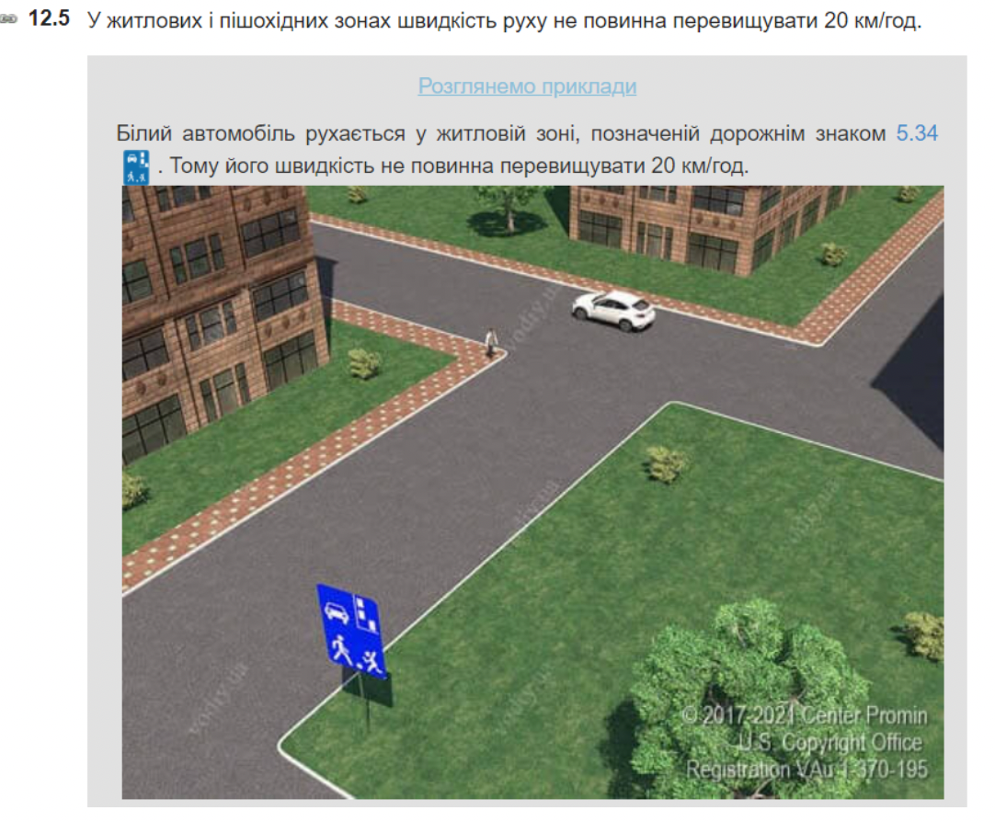

**1. Equivalence classes:**

* Since the minimum speed is not specified, the first equivalent class will include numbers <= 20
* 21 (if the price of the division can be considered 1) - max (depends on engine power and common sense of the driver)

**2. Two-point boundary values:**

* {20; 21} (if the division price is 1)

**3. Three-point boundary value:**

* {19; 20; 21} (if the division price is 1)

**Task №2**

Consider the variable DayOfWeek, whose domain is {Mon, Tue, Wed, Thu, Fri, Sat, Sun}. Which of the following is not a correct equivalence partitioning of this domain, no matter what error hypothesis is considered by a tester? Assume that each class is denoted by the curly brackets { ... }. Justify your answer  
(A) {Mon}, {Tue}, {Wed}, {Thu}, {Fri}, {Sat}, {Sun}  
(B) {Mon, Tue, Wed, Thu, Fri, Sat, Sun}  
(C) {Mon, Tue, Wed}, {Mon, Thu, Fri}, {Tue, Sat, Sun} (D) {Mon, Tue, Sat}, {Sun, Thu}, {Wed, Fri}

**Answer:** С {Mon, Tue, Wed}, {Mon, Thu, Fri}, {Tue, Sat, Sun}

Because Mon, Tue belong to different equivalence classes at the same time, and this can not be.

**Task №3**

We are testing payments on a Web-store. Based on the specified payment method (pic below), create a test cases using equivalence partitioning and two-point boundary value methods. Use template: “Verify that...”

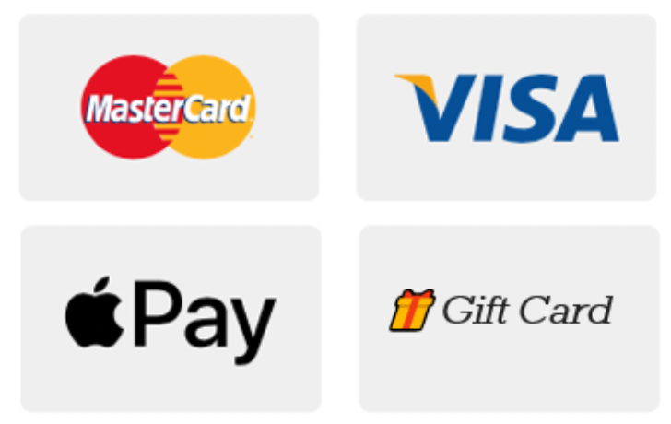

**Breakdown into equivalence classes:**

Each type of payment can be considered a separate class of equivalence:

1. Verify that user is able to pay by MasterCard
2. Verify that user is able to pay by Visa
3. Verify that user is able to pay by Apple Pay
4. Verify that user is able to pay by Gift Card

**Two-point boundary values:**

1. If it is possible to place an order for the minimum cost (for example, 1 cent) and the maximum possible (according to the requirements for this online store) and pay in all ways
2. Place an order for a larger amount outside the limit and pay for it
3. With 1 cent less than the cost of the order on the card, check whether the transaction will be completed by paying for the order
4. Make a payment by card with a balance of 0.00
5. Pay for an order in an amount larger than that specified in the Gift Card